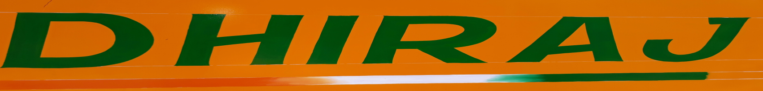

**C-12 Meerut Road Indl Area Ghaziabad-201003 (U.P) INDIA**

**Mob: +91-9818211880 Email: anchit3705@gmail.com**

**Website:** [**www.dhirajcranes.com**](http://www.dhirajcranes.com)

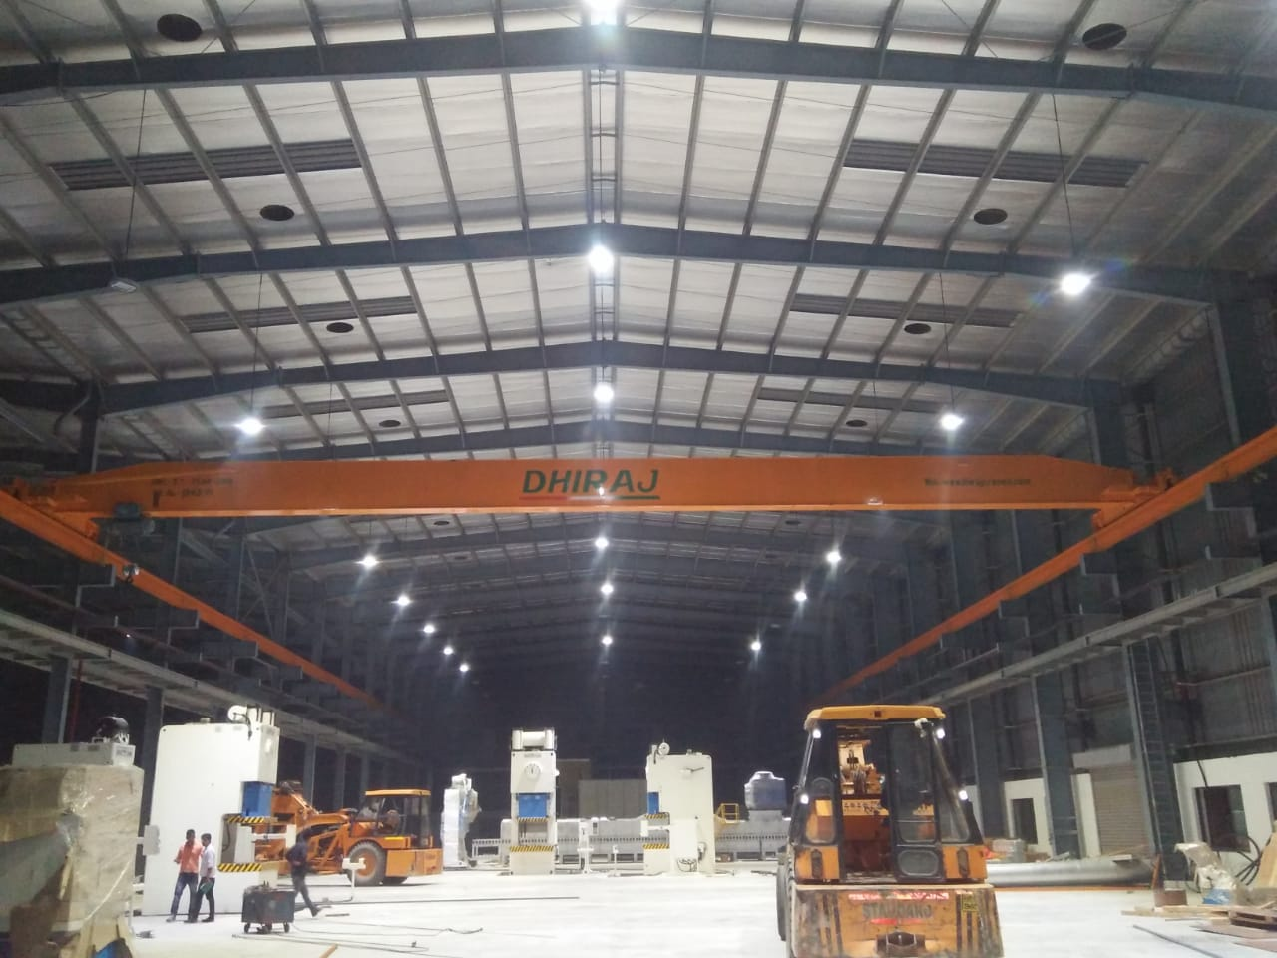

|  |
| --- |
| **Works :**  **C-12, Meerut Road Indl. Area**  **Ghaziabad -20100-U.P (India)** |

**DHIRAJ ENTERPRISES**

**Tel: 011-22236219**

|  |
| --- |
| **Office :**  **A-602, MAYUR DHWAJ APTT.**  **PLOT NO 60 IP EXTN DELHI-92** |

**Fax: 011-22236218**

**Mob: 9818211880**

**E-mail: anchit3705@gmail.com**

**To,**

**The Purchase Department**

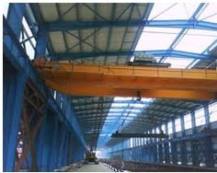

**Square Yard 4000**

**Dhiraj Cranes,** incorporated in 1972, has since supplied and Commissioned more the 1000 cranes Nation wide,

**Number of Employee - 88**

**MANUFACTURING FACULTY :**

* **Overhead Crane (EOT, HOT)**
* **Motorized Jib cranes**
* **Gantry / Semigolliath / Golliath cranes**
* **Grabbing Cranes**
* **Electric Wire Rope Hoist**
* **Freight elevators and allied material handling equipments**
* **We also undertake heavy fabrication and erection jobs.**

**MATRIX**

|  |  |  |  |
| --- | --- | --- | --- |
| **ITEM DESCRIPTION** | | **RANGE** | **SPAN** |
| **1.** | **EOT CRANE** | **IT-60T** | **3M - 35M** |
|  |  |  |  |
| **2.** | **MOTORISED JIB CRANE** | **0.25 T - 5T** | **1.5M - 6M** |
|  |  |  |  |
| **3.** | **GANTRY** | **IT - 60T** | **3M -35M** |
|  |  |  |  |
| **4.** | **GRABBING CRANES** | **5 T - 20T** | **10M - 25M** |
|  |  |  |  |
| **5.** | **ELECTRIC HOIST** | **0.5T - 20T** | **MOTORISED** |
|  |  |  |  |
| **6.** | **FRIGHT ELEVATORS** | **0.5T - 5T** | **UPTO TO FLOORS** |

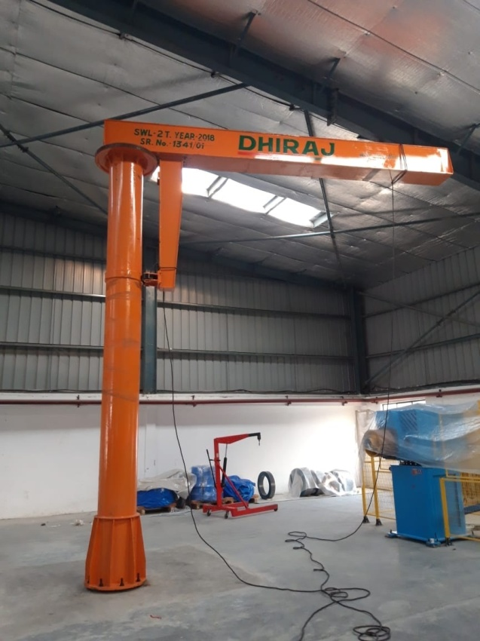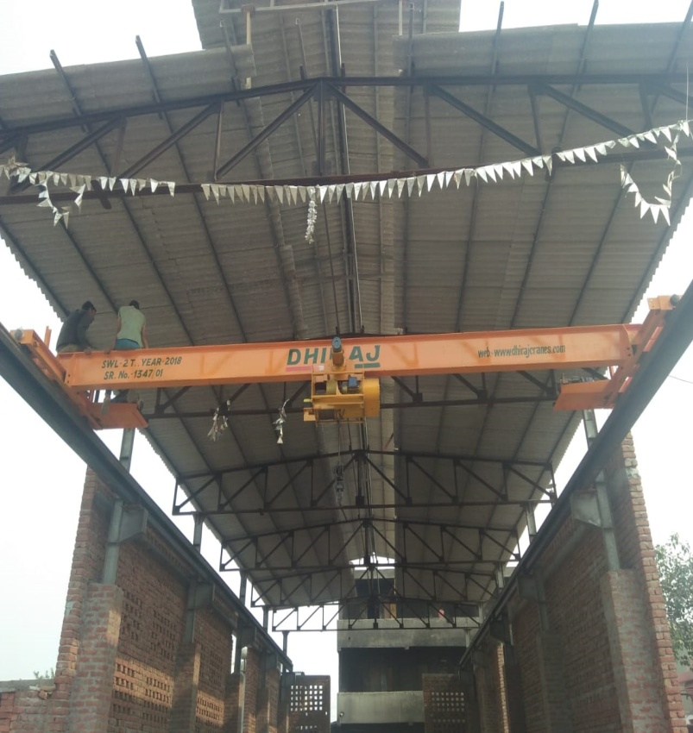

**OUR FOCUS :**

* SAFETY
* QUALITY
* PRODUCTIVITY
* ON TIME DELIVERY
* AFTER SALE & SERVICE

**OUR STRENGTH :**

* APPLICATION Engg.
* DESIGN Engg.
* ELECTRONIC Engg.

(PLC PROGRAMMER)

* AFTER SALE & SERVICE

**OUR MAJOR CUSTOMER :**

* JSPL 
* INDIAN OIL 
* DELHI METRO 
* BSES 
* DALMIA GROUP 
* FOOD & BEVERAGE 

**NEW PRODUCTS - COMING SOON :**

* **CUSTOMIZED SOLUTION FOR MATERIAL HANDLING**
  + - JIB CRANE
    - PNEUMATIC GRIPPER
    - MECHANICAL TACKLE
    - 713 SERIES AM
    - 600 SERIES ARM
    - ARTICULATING ARM
    - ZERO GRAVITY MANIPULATOR
    - OVERHEAD RAIL SYSTEM / AIR BALANCER / MANUAL CHAIN HOIST

(AS PER CUSTOMER REQUIREMENT)

* **FASTENING & TIGHTENING SYSTEM (CUSTOMIZED SOLUTION)**
  + - TORQUE TUBE
    - MULTI SPINDLE
    - CROW FOOT
    - REACTION ARM
    - QTA ARM
    - TOOL HOLDER - SWILL 3600
    - MANUAL & MOTORIZED CONVEYOR FOR JOB MOVEMENT



**QUESTION :**

